Google Rich Snippets – Magento 2
User Guide

Table Of Contents

Preface ……………………………………………………...……………………………………………………………….3
Installation Guide …………………………………..….……………………………………………………………...4
Back-end Example.………………………...................................................................…………..5
Front-end Example …………………….....................................................................…………..9

Preface

The Mageants Google Rich Snippets extension provides the customers with a better shopping experience use of this extension. Greatly enhance your snippets in the search results.
Along with that, you can add breadcrumbs to your snippets, Display products rating, enable rich snippets on category pages, show starting price data and create snippets with your organization logo and name

Installation
There are two ways of installing extension in magento2.
- Using COMMAND LINE.
- Manually Install extension.

Option 1: Magento 2 install extension using COMMAND LINE (Recommended) Follow below steps to install extension from the command line.
Step 1: Download the extension and unzip it.

Step 2: Upload it to code directory in your magento installation’s app directory If code directory does not exists then create.

Step 3: Disable the cache under System -> Cache Management.

Step 4: Enter the following at the command line: php bin/magento setup:upgrade

Step 5: Once you complete above steps log out and log in back to the admin panel and switch to Stores -> Configuration -> Mageants → SEO Rich Data , the module will be displayed in the admin panel.

Option 2: Magento 2 install extension manually

Step 1: Download the extension and unzip it.
Step 2: Upload it to code directory in your magento installation’s app directory If code directory does not exists then create.
Step 3: Disable the cache under System -> Cache Management Edit app/etc/config.php file and add one line code: ‘Mageants_Richsnippets’ => 1
Step 4: Disable the cache under System -> Cache Management

Step 5: Once you complete above steps log out and log in back to the admin panel and switch to Stores -> Configuration -> Mageants → SEO Rich Data , the module will be displayed in the admin panel.

Back-end Example

CONFIGURATION
After Installation of Extension login to magento admin panel for set configuration of the extension.
You can find configuration at Stores -> Configuration -> Mageants -> SEO Rich Data

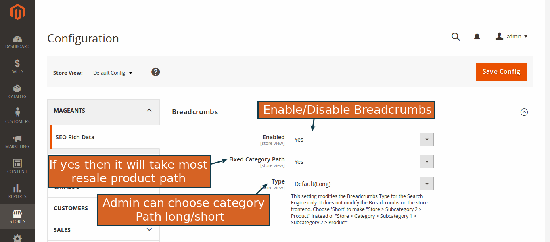

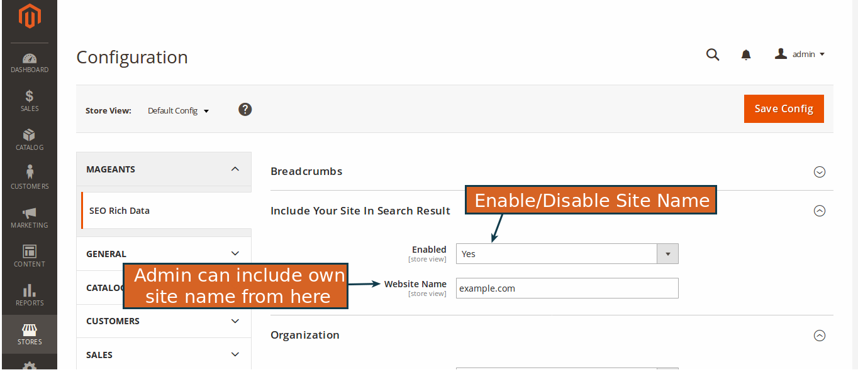

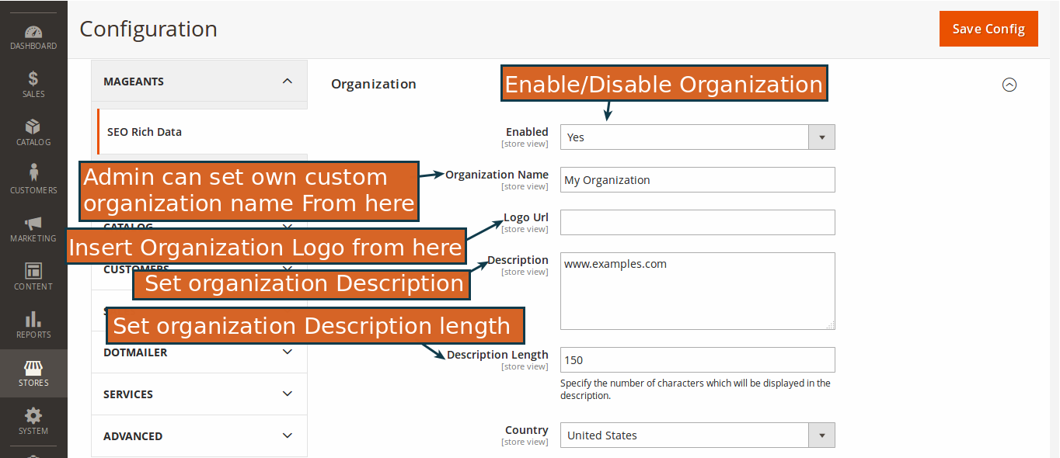

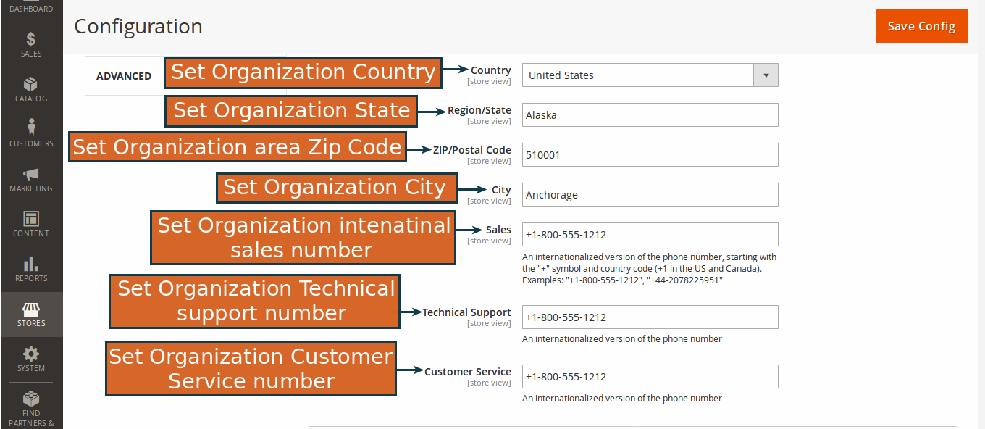

Admin can add the new free shipping bar or edit from backend as follow.

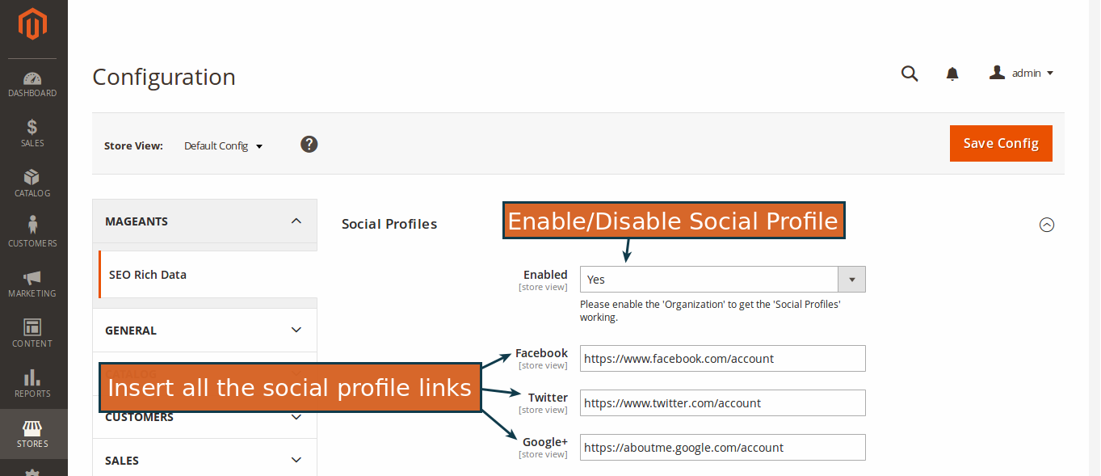

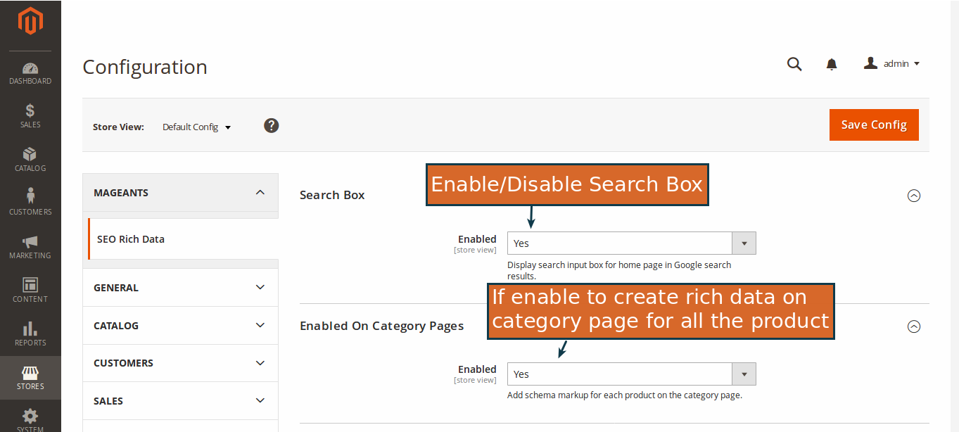

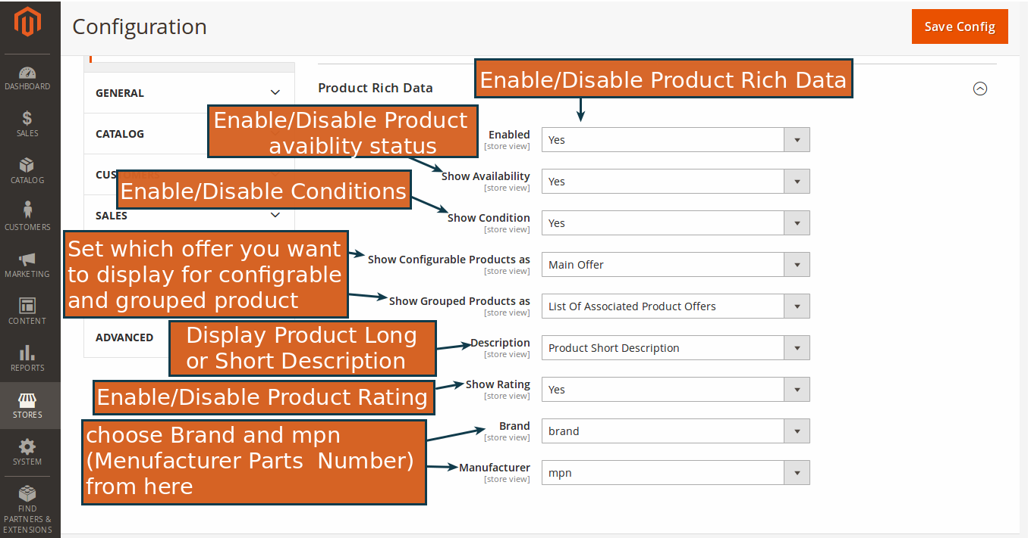

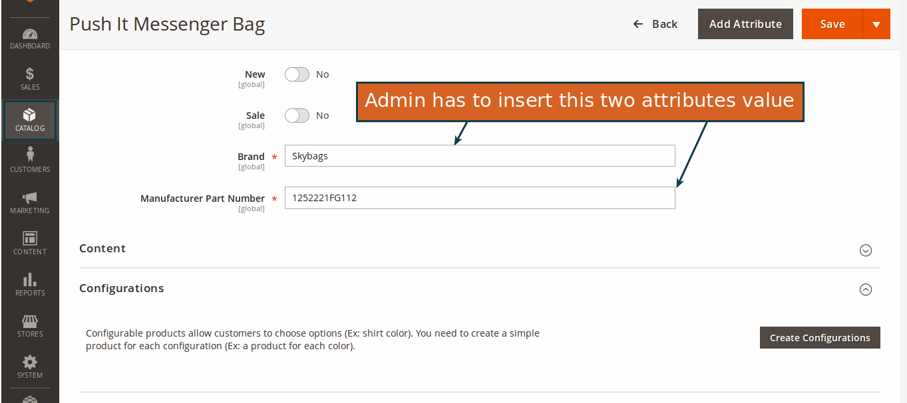
Except this, admin has to insert value of attribute in product page Catalog → Product and click on the product.

Front-end Example

The Google Rich Snippets display information on the google page.

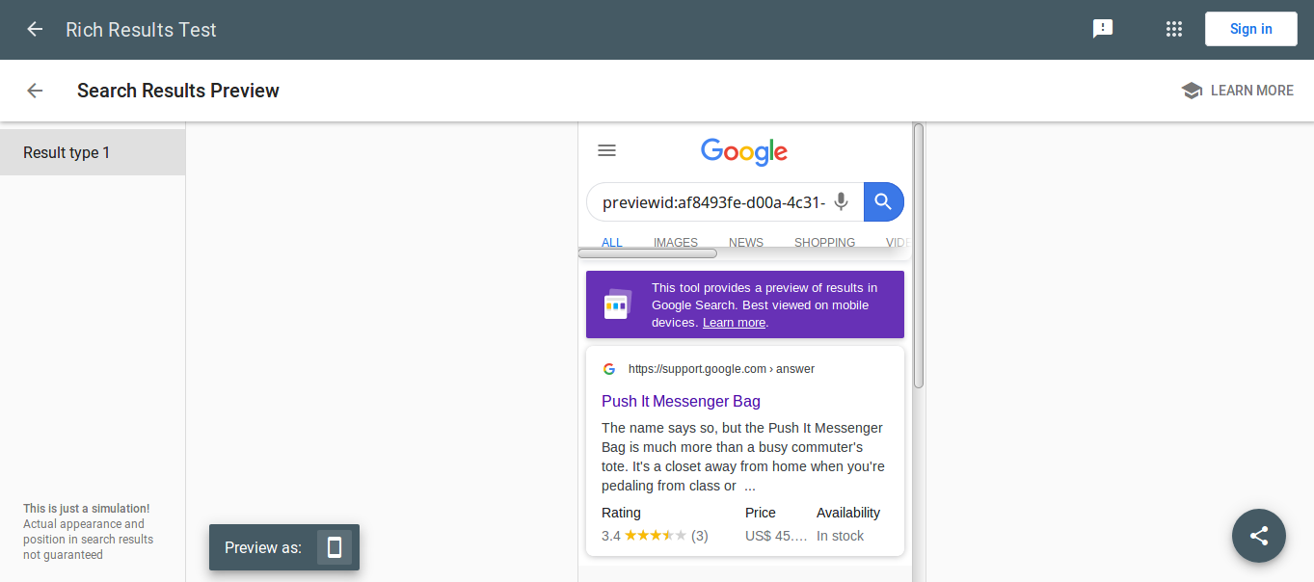

The Data has test on Google Data Testing Tool (You Can get all the information over here).

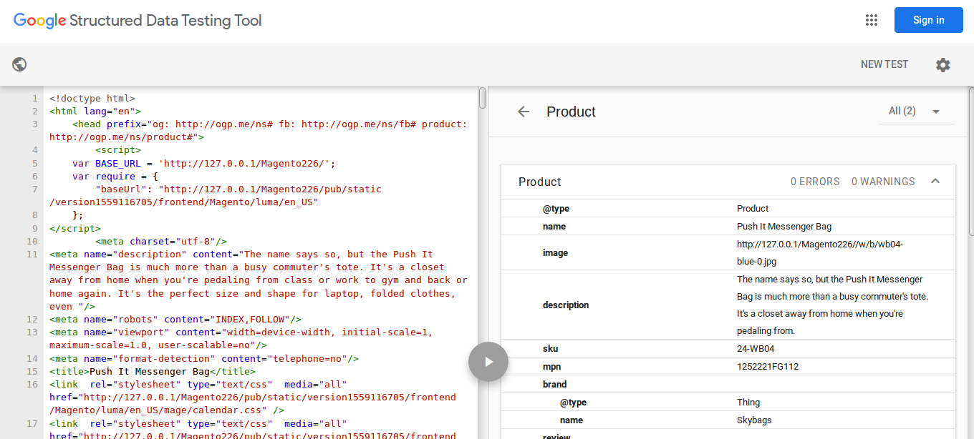

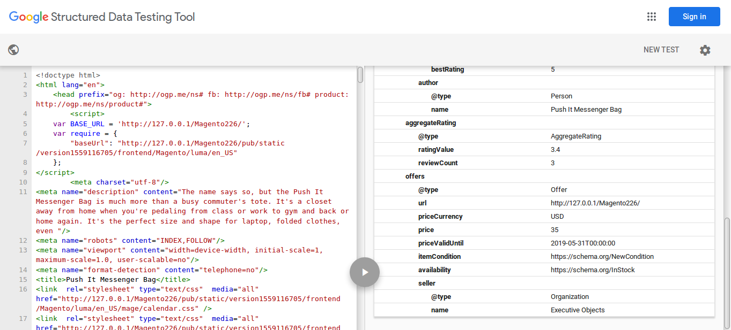

Thank you!

Should you have any questions or feature suggestions, please contact us at:
http://mageants.com/contactus

Your feedback is absolutely welcome!

